Newsletter № 2

  - HEALTHY EATING AND MOVEMENT FOR A BETTER QUALITY OF LIFE

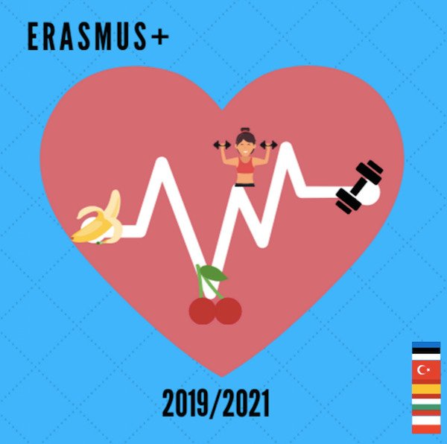
Meeting in Bulgaria, Chirpan city
March 2022
The title of LTTA is “You are what you eat - How to have a balanced diet”.

Outcomes and outputs:
- participants will develop a better understanding of the prnciples of healthy eating, how to read and interpret labels
- participants will have had practical tasks related to shopping for healthy food, which they will transfer into their daily lives
- parents in the host school will become more involved in the supervision of their children’s eating habits
- improved knowledge of the Bulgarian education system, culture, traditions, cuisine
- students’ presentations, journals, dishes
- evaluation report and materials and sample activities produced during C3 (completed by BG within a month)
- materials for the two final brochures (synthesised by the host partner)
- evaluation forms
- certificates of attendance, Europass mobility documents
- photos
The activities combine attending regular classes, visit to school cafeteria, school premises and topic-related workshops, seminars etc. They are organized during the regular working hours, with the exception of practical tasks and cultural activities and events which take place outside the school. Cultural tours/events/activities are meant to strengthen the intercultural, interactional and personal component of projects. Participants are expected to bond and create long-lasting friendships.

Our project on https://twinspace.etwinning.net/93787

All meeting material here: https://sites.google.com/view/healthy-eating-and-movement-fo/%D1%813?authuser=0

