Newsletter № 2

  - HEALTHY EATING AND MOVEMENT FOR A BETTER QUALITY OF LIFE

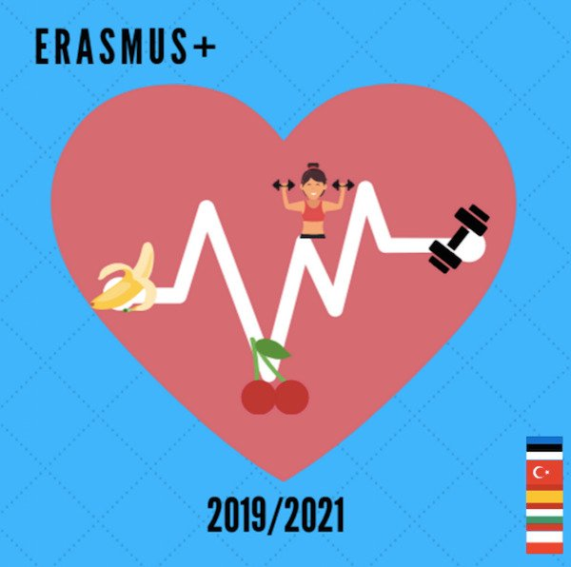
Meeting in Estonia, Kohtla-Järve city
November 2021
The title of LTTA is “Hiking and outdoor activities”.

The schedule includes:
- Presentation of goals and meeting schedule
- Workshop: Ergotherapy, Brain gymnastik, outdoor activity training, GPS art, LEGO activity games, Reflector, Rubber bands, Picasso game, orienteering games, dance teraphy, nature hiking, Cup and plate games
- Meeting with the school
- Round table on what was done by the project: created the eTwinning project, the FB group
- Cultural Activity: Oil Shale Museum, Wittenstein Time Centre in Paide Tower, Mainers museum, Palmse museum
Estonian Dairy Museum + Workshop (healthy food)
- A leadership meeting, followed by discussions in small groups, during which counselors discuss the methodology for selecting and involving students and their parents, coordinators discuss the content of the next meetings and what each team needs to do in the future, etc.
- Appreciation
- delivery of certificates
As a result of these activities, we will obtain the following outcomes and outputs:
- participants will practise a set of activities that they can perform outdoors, either as a school activity or with their parents and friends
- improved knowledge of the Estonia education system, culture, traditions, cuisine
- evaluation report and materials and sample activities produced during C5 (completed by EST within a month)
- materials for the two final brochures (synthesised by the host partner)
- evaluation forms
- certificates of attendance, Europass mobility documents
- photos

The activities combine attending regular classes, school-based workshops and outdoor activities etc. Estonia team are organized during the regular working hours, with the exception of the field trip and cultural activities and events which take place outside the school. Cultural tours/events/activities are meant to strengthen the intercultural, interactional and personal component of projects. Participants are expected to bond and create long-lasting friendships.
As a result teachers develop their knowledge of other systems of education, observe practices in the Estonia school, exchange opinions, ideas, suggestions with partners.
Teachers themselves become more fluent in English and improve their competences in solving problems, organising international events. They also improve communication, interpersonal and social skills.

Our project on https://twinspace.etwinning.net/93787

All meeting material here: https://sites.google.com/view/healthy-eating-and-movement-fo/c5

